Tech Etiquette
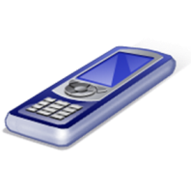
*Do remember to put your phone away when you are talking in person with others, at the dinner table, interacting with store clerks, in school, in church…in other words, any place where your attention should be on others. “Be” with the people you are supposed to “be with”.
*Remember to excuse yourself and take/make your call in a quiet place away from others.
*Do remember to speak quietly while on the phone.
*Do remember to call/text at reasonable hours, not late at night. Unless you are a brain surgeon setting up surgery for a critical patient, it can probably wait until tomorrow.
*Do let your friends know when you are, or are not, available. Set a good example.
*Get in the habit of turning off your phone during homework.
*When doing homework on the computer do not try to check your Facebook account “real quick”. We all know that is next to impossible. STAY STRONG and focus only on the homework!
*Remember that once you hit SEND, it instantly becomes available to anyone in the world with Copy and Paste, Forward etc. Always type only what you would be proud of if the e mail or text accidently went to Jesus.
*Do exercise control over your devices instead of them controlling you. Prioritize your time. Turn off your phone to avoid being drawn to the “buzz”. Set an alarm so that you don’t “come to” hours later to find you are still surfing your computer.
*Our new technology devices are not “bad”—it is all in how we choose to use them. Be a good example to those around you, kids and adults alike!

